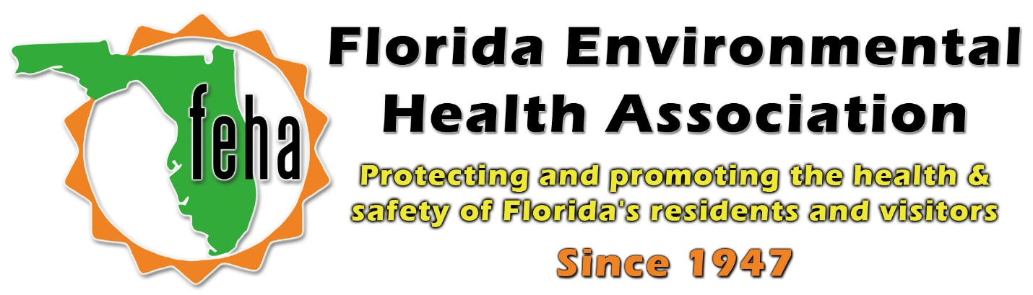

2021 Virtual FEHA AEM
October 13th-15th 2021
Session Title: Advanced Water Chemistry & Test Kit Interferences
Date: Friday October 15th
Time: 9am-10:30am
Speaker: Lauren Broom, R.S.
Owner of Space Coast Pool School, LLC

Start: 9am
End: 10:30am

