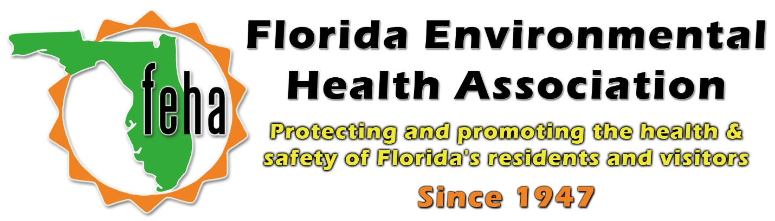

2021 Virtual FEHA AEM
October 13th-15th 2021
Session Title: Homeland Security Grant Program Funding – an Overview
Date: Thursday October 14th
Time: 9am-10:30am
Speaker: Garry Lisiewski, Tampa Bay UASI Program Manager, with significant contribution provided by Benjamin Puckett, Planner IV, Florida Department of Law Enforcement

Start: 9am
End: 10:30am

